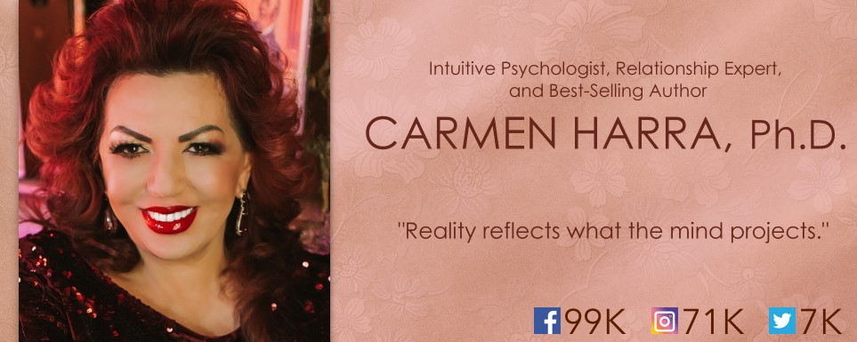

CHANGE YOUR KARMA, CHANGE YOUR LIFE
Get ready to discover the secrets to transforming your relationships with your partner, family, friends, and yourself!
Do you feel like you attract the same sort of disappointing relationships over and over again? Maybe it seems like every lover you meet is a cheater or liar, and you’re just fed up with it. Maybe you feel stuck on a plateau with your current partner, unable to escape recurring arguments. You’re not the problem—your karma is.
If a relationship (or lack of) is causing you pain, confusion, doubt, or uncertainty, then old, lingering karma may be to blame. World-renowned intuitive psychologist Dr. Carmen Harra unwinds your most tangled bonds and shares how you can heal your connections—all by healing your karma! Carmen was dubbed “The Queen of Karma” by New York Post, so it only makes sense that she recently penned The Karma Queens’ Guide to Relationships, a golden manual of relationship wisdom from both spiritual and practical standpoints.
You see, karma is both the problem and solution; it’s so much more than the misconceived “what goes around comes around.” Karma is the accumulation of your thoughts, intentions, and actions, both good and bad. The energy of karma manifests into everyday life. It gets attached to your consciousness until you become aware of it. You carry your karma with you like luggage on a trip, so your experiences in this lifetime may draw their origins in past lives. The doors of infinite possibilities open when you acknowledge the three truths of karma: that it’s the sum of every thought, intention, and action, that it’s always reversible, and that resolving karma requires work. Then, you can master your karma and clear blockages from your predestined path.
Your personal karma reflects the kinds of relationships you experience; it’s the reason you must learn certain lessons, overcome certain challenges, and meet certain people. But if your karma is impure, you will attract a series of complicated people. You may become trapped in a cycle of bringing in partners with the same tendencies, and your relationships may fail time and time again, oftentimes without you understanding why. Karma spills onto your relationships with others, affecting your human bonds to the breaking point, until you acknowledge and resolve it once and for all. Then, you can finally progress towards permanently fulfilling relationships.
Carmen explains how to:
Get to the root of the karmic problem to jumpstart healing,
Determine if your accumulated karma is preventing you from meeting your romantic soul mate or is creating issues in your current relationship,
Understand the real reason behind your partner's actions (whether they’re karmic or not!),
Deepen physical, emotional, mental, and spiritual intimacy with your loved one,
Overcome former betrayals, extend forgiveness to those who have hurt you, and purify your emotions,
Reverse the effects of negative karma and finally break free of karmic cycles,
Calculate divine timing and use it to your advantage,
Decode compatibility between you and your love interest on a divine level,
Learn to be a better friend, family member, romantic partner, and member of your community.
Carmen illustrates the small but mindful steps we must take each day to resolve our outstanding karma, from modifying behavior, establishing unwavering self-love, and practicing exercises to purify energy. Miraculous relationships await when we erase negative imprints from the past and create new, positive karma for a joyful future.

BIOGRAPHY
From a young age, Carmen Harra began dreaming of the big world outside the small village in which she was born. At just five years old, Carmen drowned in a river near her home in Transylvania, Romania. Her father rescued her, but the accident left Carmen forever changed, blessing her with an extraordinary gift she would later use to help millions. Before she returned to this reality, Carmen recalls passing through a tunnel of white light and into a picturesque landscape with familiar faces and serene music. This experience marked the beginning of Carmen’s paranormal journey.
In her early teens, Carmen began entering singing competitions. She knew that her vocal talents would be her saving grace, her escape from the little town with no running water and no chance for progress. Carmen quickly rose to fame, touring Europe and releasing twelve albums. All the while, she avidly studied the transcendental abilities of the mind, the teachings of Kabbalah, and the science of numerology. She was simply captivated by the possibility of communicating with those who had passed on. When she wasn’t performing, Carmen was educating herself on these ancient arts and exercising her own otherworldly abilities.
Carmen first came to America on a singing contract but soon stumbled upon a completely new career. She decided to utilize the gift that came to her naturally, and began offering sessions as an intuitive counselor in NYC. A chance encounter with a Manhattan socialite quickly spread the word about Carmen’s abilities all around town. Soon, Carmen found herself attending exclusive Upper East Side parties, billionaire balls, even making TV appearances in which she explained the powers of the mind we all unknowingly possess. She expanded her metaphysical skills by earning PhDs in Hypnosis and Alternative Healing. Carmen knew that she could better serve her clients by combining intuition with cognitive therapy, so she attained a PhD in Clinical Psychology. She began writing her first book, Everyday Karma, which has been translated into 20 different languages and sold in many parts of the world. And this was only the beginning.
For over 25 years, Carmen has thrived as a respected psychologist and acclaimed intuitive. She’s counseled over 40,000 clients from all walks of life, wrote seven best-selling books (and is working on her eighth!), hosted hundreds of radio shows and seminars, and has made countless appearances on national and international TV programs.
Carmen splits her time between Miami and New York and continues to live out her mission, changing one life at a time.

TV & MAGAZINES
Carmen has been featured in numerous publications such as the New York Times, New York Post, New York Daily News, Vogue, New York Magazine, US Weekly, V Magazine, Elle Magazine, and many more. She’s appeared on TV programs like Good Morning America, The View, Fox News, the Today show, Good Day New York, CBS’ The Early Show, ABC’s What's the Buzz, Telemundo, America Vive, Primer Impacto, New York Nightly News with Chuck Scarborough, NBC's the 10! show, The Strategy Room, BetterTV, NBC Tampa Morning Show, NBC Miami Morning Show, ABC Jacksonville Morning Show, Channel 11 Morning Show, Channel 6 in Paris, KCAL 9 news, QVC with her own jewelry line, Happy Hour on ProTV International, etc.

RADIO SHOWS
Over the last 15 years, Carmen has hosted her own radio shows on Sirius Satellite, Healthy Life Network, Contact Talk Radio, Hay House Radio, WOR Radio, and WABC Radio. She’s been featured on air with Barbara Walters, Mancow, Montel Williams, Valder Beebe, Hannity and Colmes, and on dozens more. Currently she hosts a popular call-in show on OMTimes Radio named Miracle Guidance for Everyday Life.

SPEAKING ENGAGEMENTS
Carmen has taught engaging, successful classes at the Learning Annex, Omega Institute, UStream TV, Bowery Poetry Club, and Hay House’s I Can Do It! She’s an expert in a wide range of spiritual and self-help topics including relationships, intuition, mediumship, numerology, predictions, psychology, natural health, karma, and empowerment.

BOOKS
1.) Everyday Karma, Random House, Inc., 2002
ISBN: 0-345-45511-8

2.) Decoding Your Destiny, Simon & Schuster, Inc., 2006
ISBN-13: 978-1-58270-143-1
ISBN-10: 1-58270-143-1

3.) Signs, Symbols, & Secrets: Decoding the DaVinci Code, AuthorHouse, 2006
ISBN-10: 1425952577
ISBN-13: 978-1425952570

4.) The Trinity of Health, BookSurge, 2007
ISBN: 1-4196-6562-6
ISBN-13: 978-1419665622

5.) The Eleven Eternal Principles, Random House, Inc., 2009
ISBN: 978-1-58091-197-9

6.) Wholeliness: Embracing the Sacred Unity That Heals Our World, Hay House, Inc., 2011
Tradepaper ISBN: 978-1-4019-3144-5
Digital ISBN: 978-1-4019-3145-2

7.) The Karma Queens’ Guide to Relationships: The Truth About Karma in Relationships, Tarcher/Penguin, Inc., 2015
Tradepaper ISBN: 978-1-4019-3144-5
ISBN-10: 0399173900
ISBN-13: 978-0399173905

CONTACT
Carmen's Information:
Website: www.CarmenHarra.com
Email: CarmenHarra@aol.com
Mobile: (917)771-6035

